StudentHub Portal - Practical 1 & 2 Design Layouts & Outputs
This document contains the complete visual sitemap, wireframes, and final browser webpage outputs for the StudentHub portal.

1. Project Site Sitemap Diagram
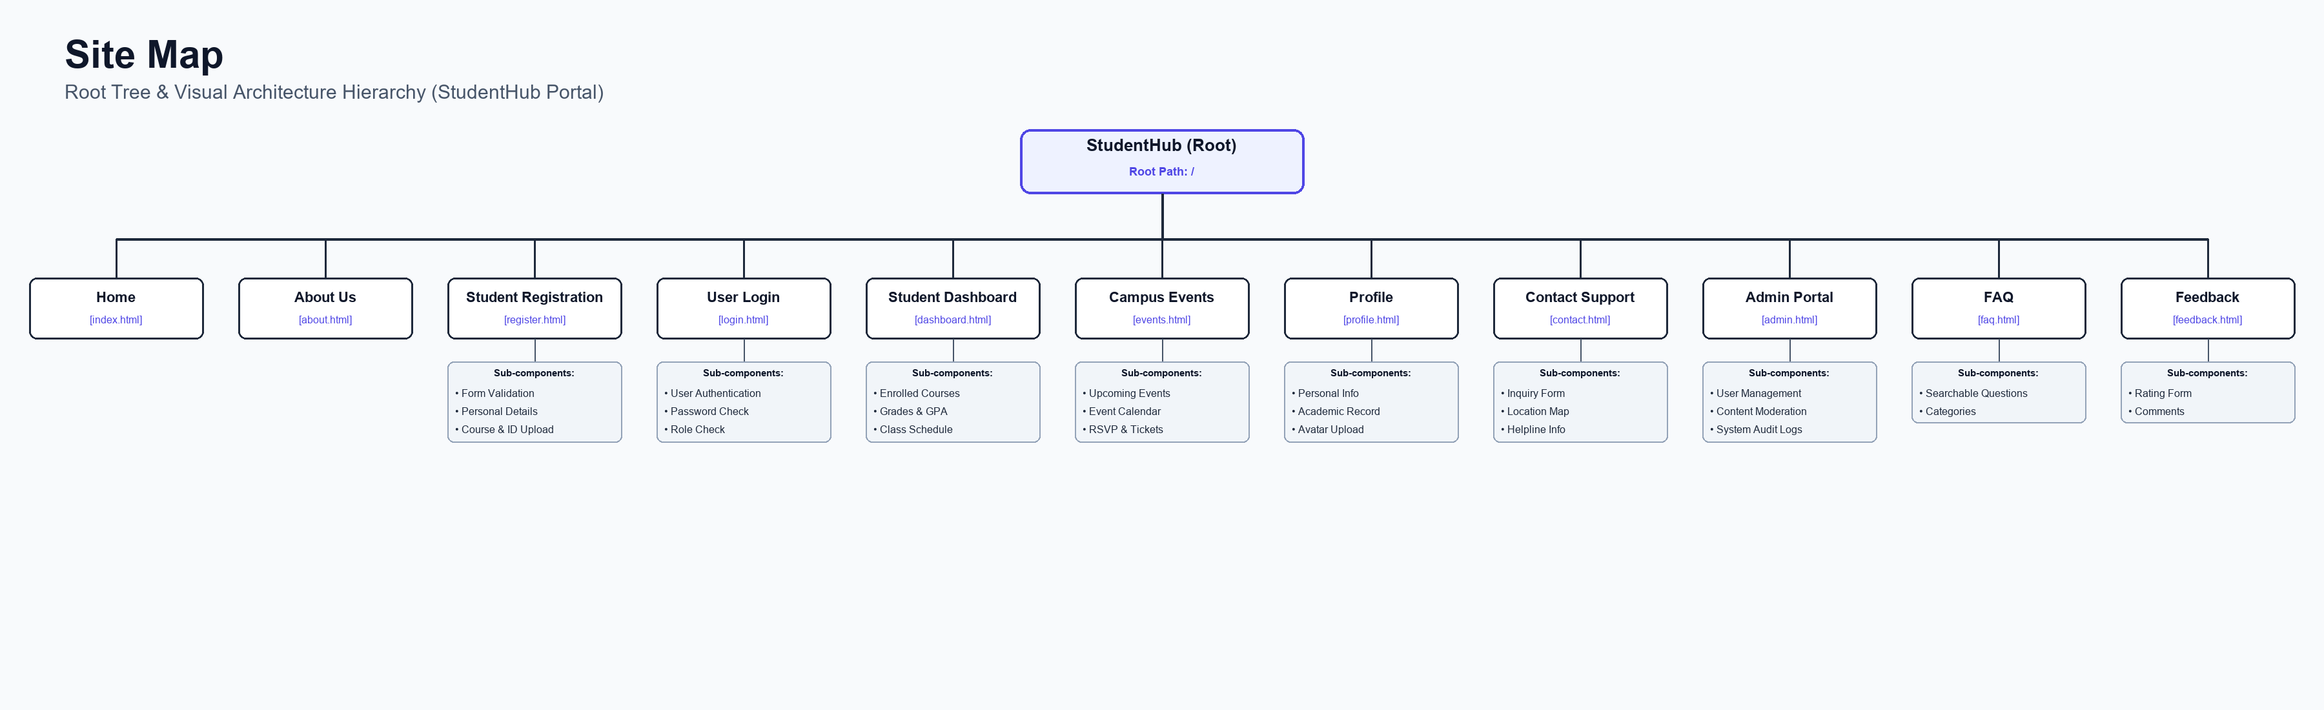
Figure: High-Resolution Visual Sitemap Hierarchy

2. Low-Fidelity Wireframes
Below is the visual mockup collage of all 11 page wireframes, followed by individual page wireframes.
Figure: Low-Fidelity Visual Wireframe Collage

Wireframe - Home Page (index.html)
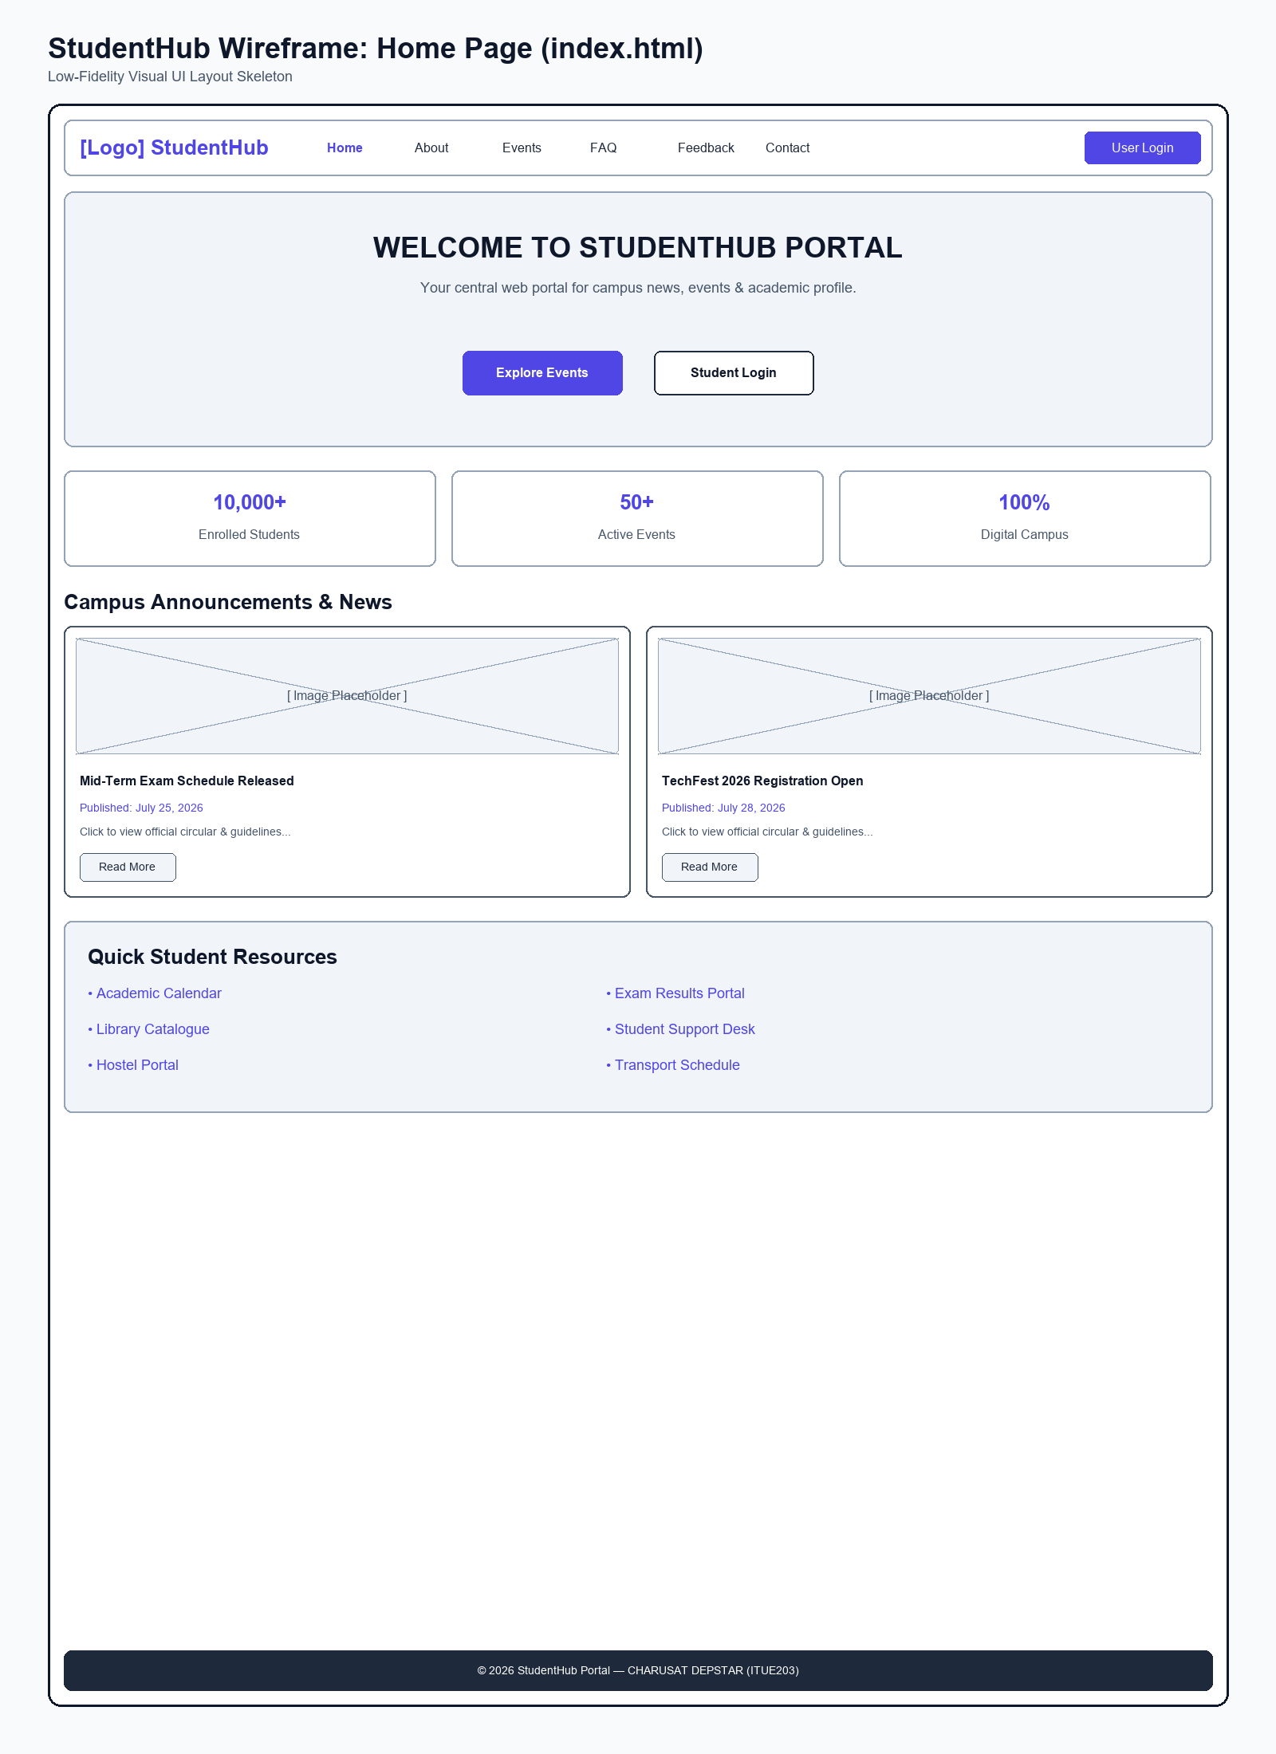
Figure: Wireframe Blueprint layout for Home Page

Wireframe - About Us Page (about.html)
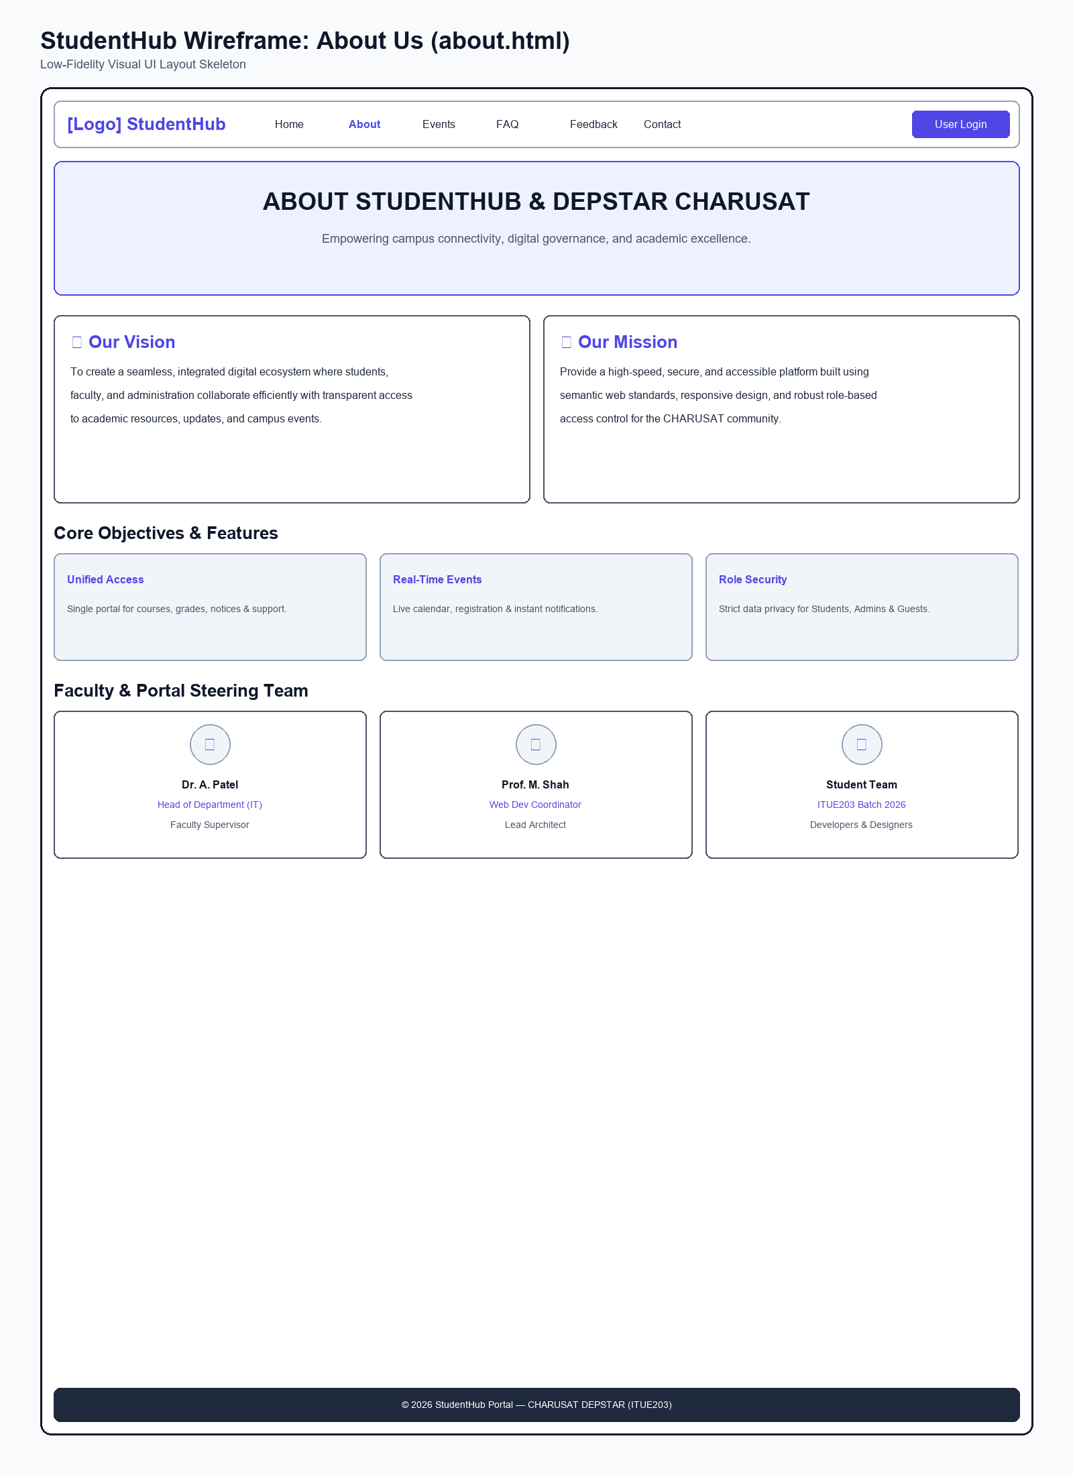
Figure: Wireframe Blueprint layout for About Us Page

Wireframe - Student Registration Page (register.html)
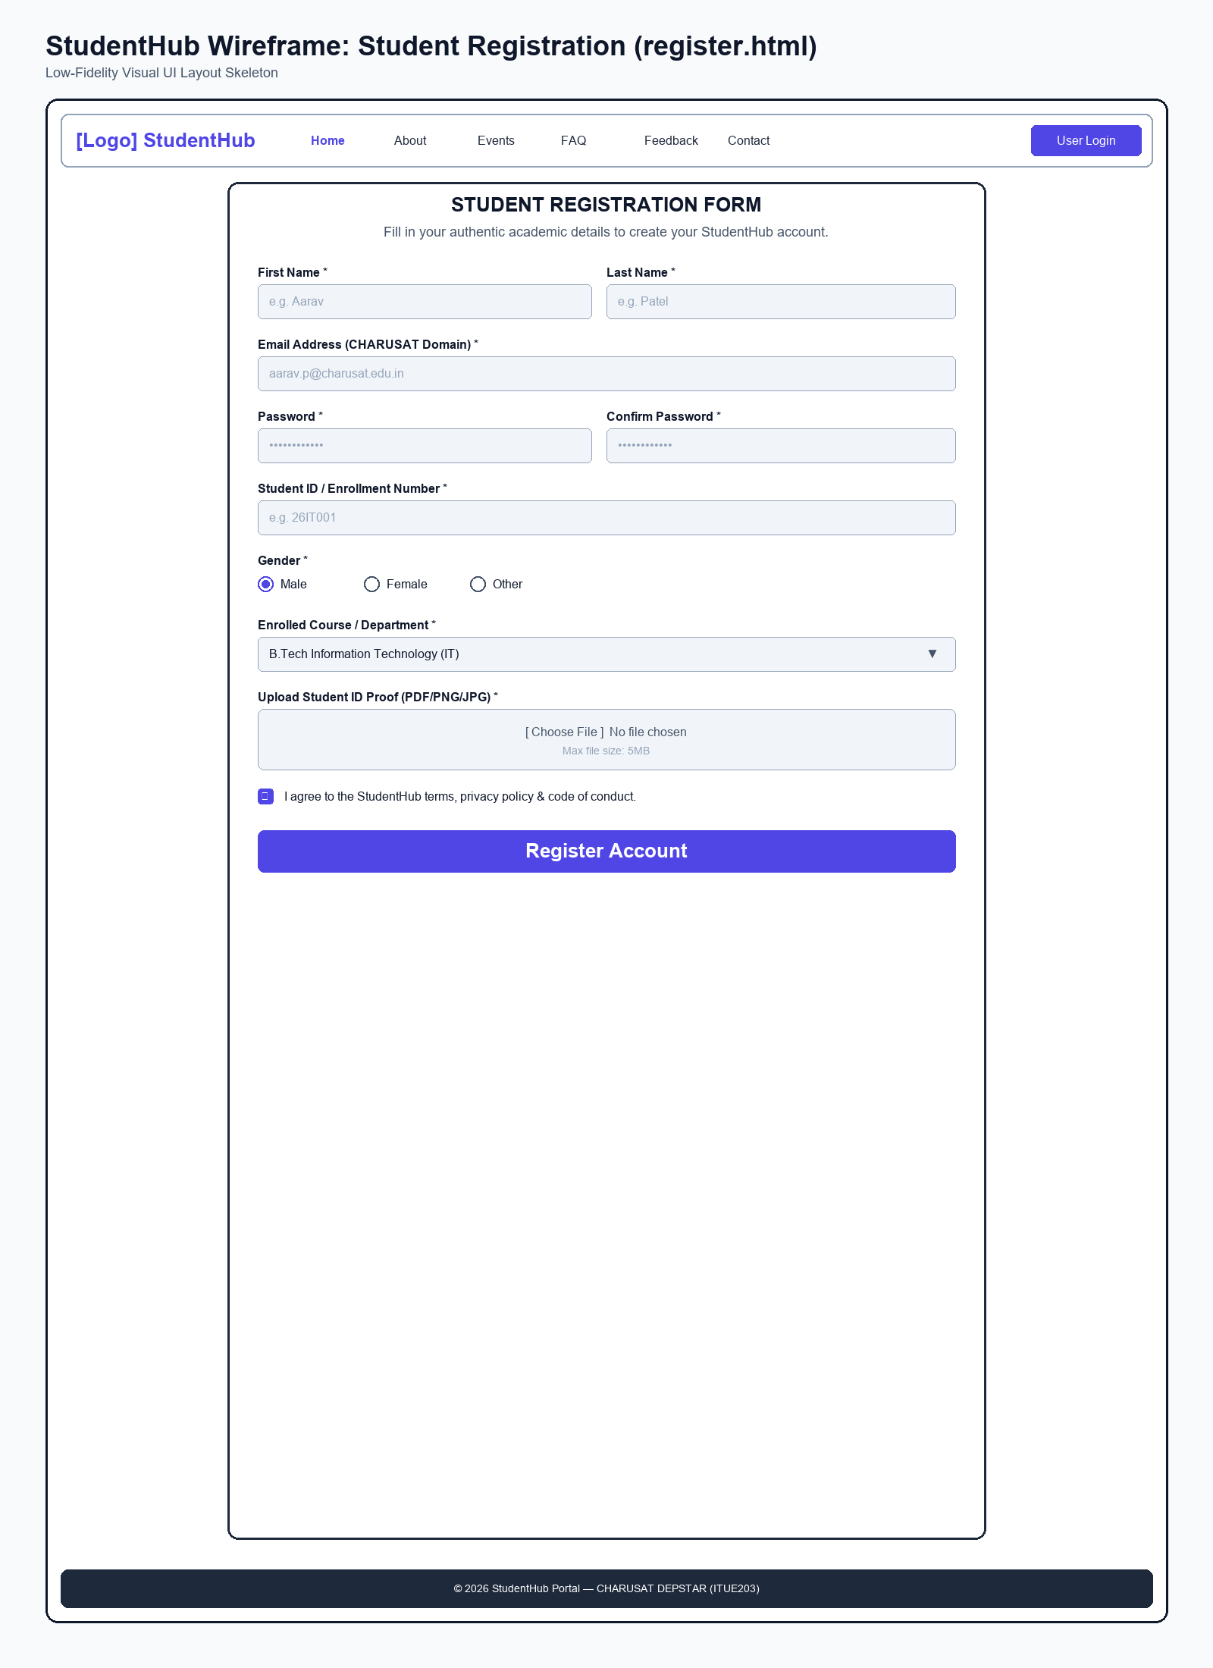
Figure: Wireframe Blueprint layout for Student Registration Page

Wireframe - User Login Page (login.html)
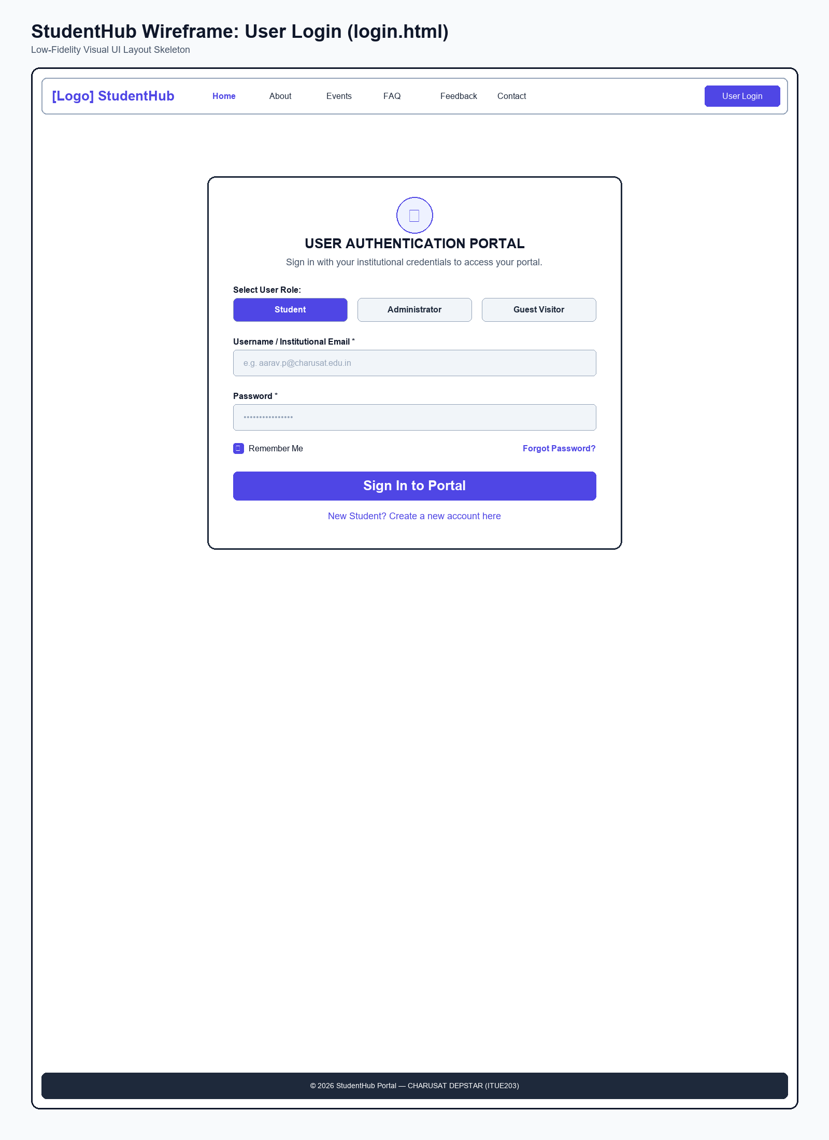
Figure: Wireframe Blueprint layout for User Login Page

Wireframe - Student Dashboard Page (dashboard.html)
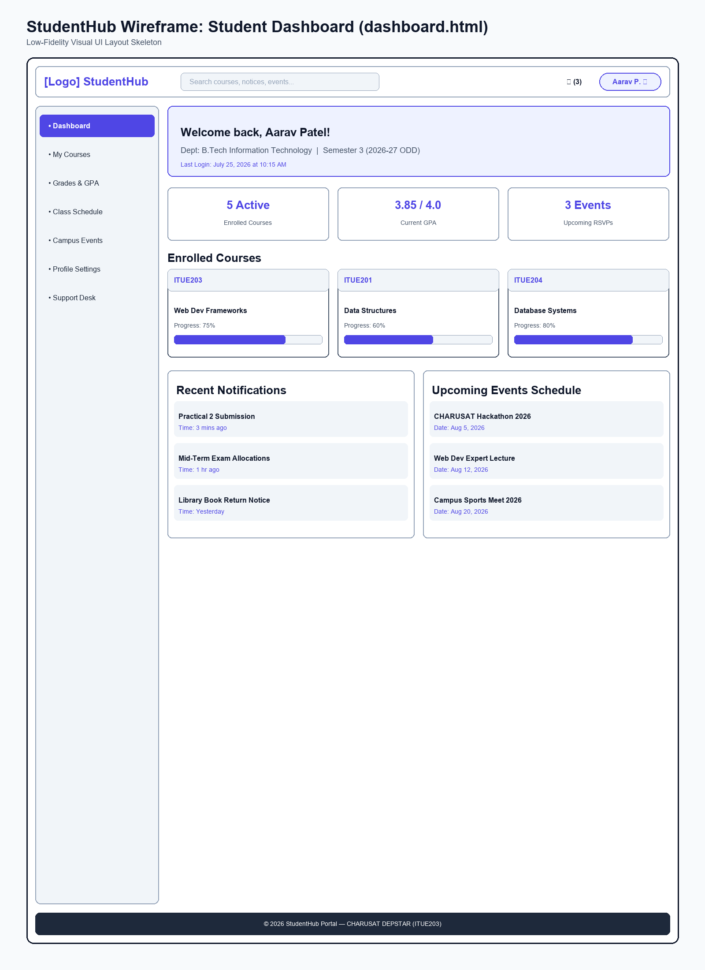
Figure: Wireframe Blueprint layout for Student Dashboard Page

Wireframe - Campus Events Page (events.html)
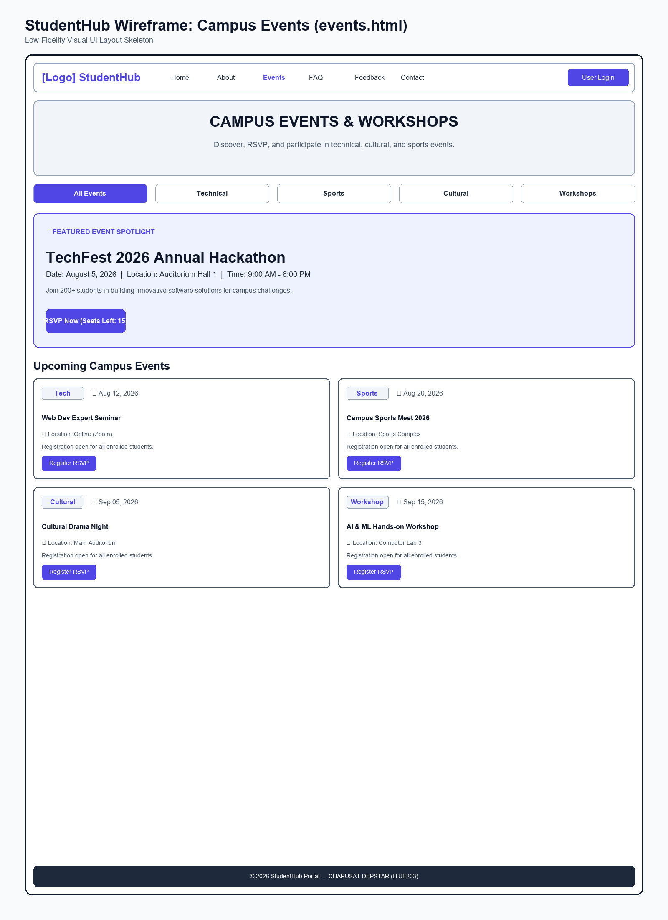
Figure: Wireframe Blueprint layout for Campus Events Page

Wireframe - Student Profile Page (profile.html)
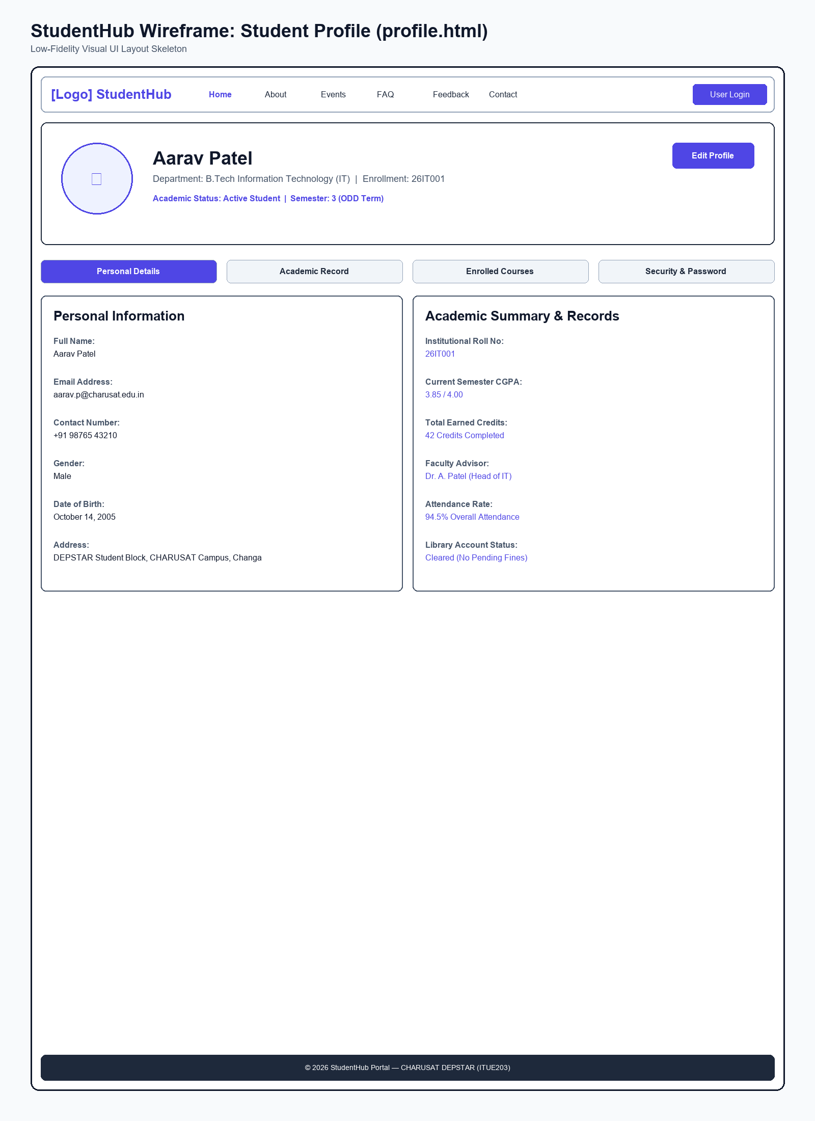
Figure: Wireframe Blueprint layout for Student Profile Page

Wireframe - Contact Support Page (contact.html)
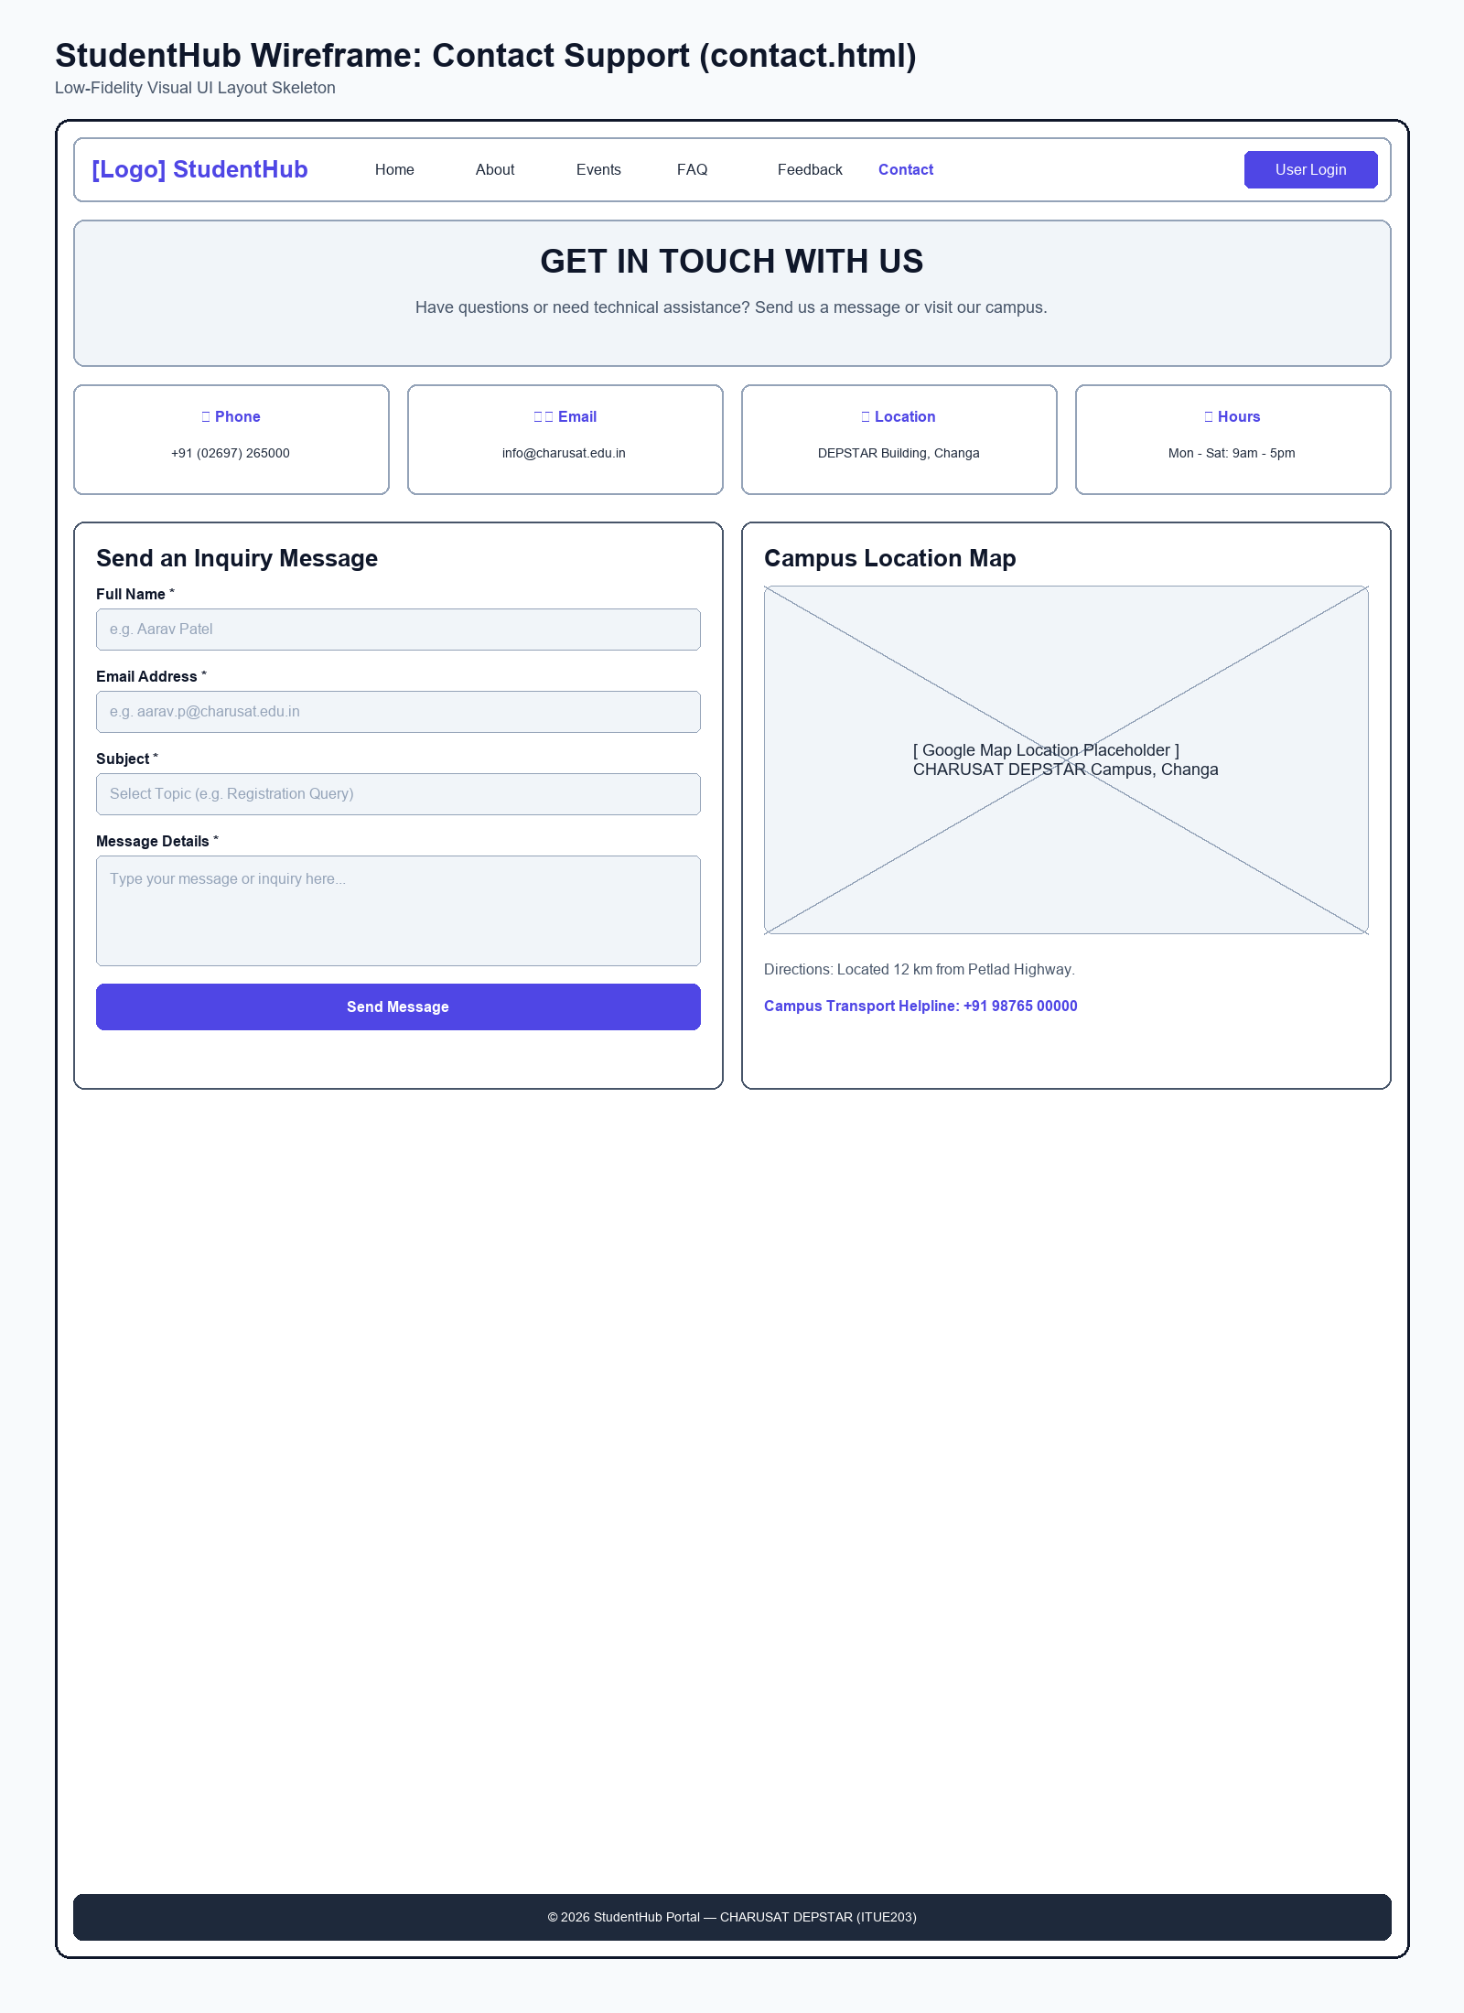
Figure: Wireframe Blueprint layout for Contact Support Page

Wireframe - Admin Portal Page (admin.html)
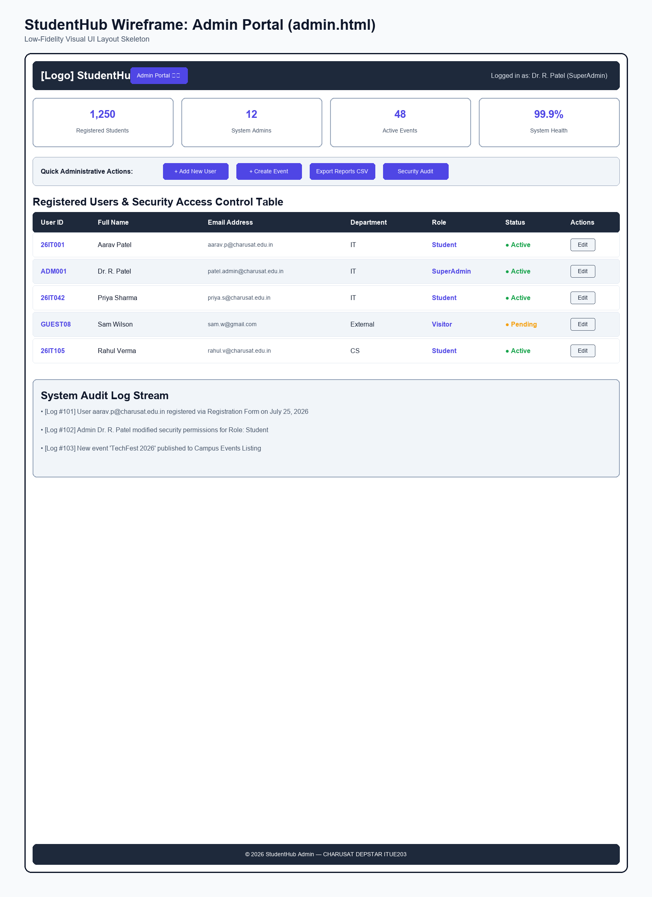
Figure: Wireframe Blueprint layout for Admin Portal Page

Wireframe - FAQ Page (faq.html)
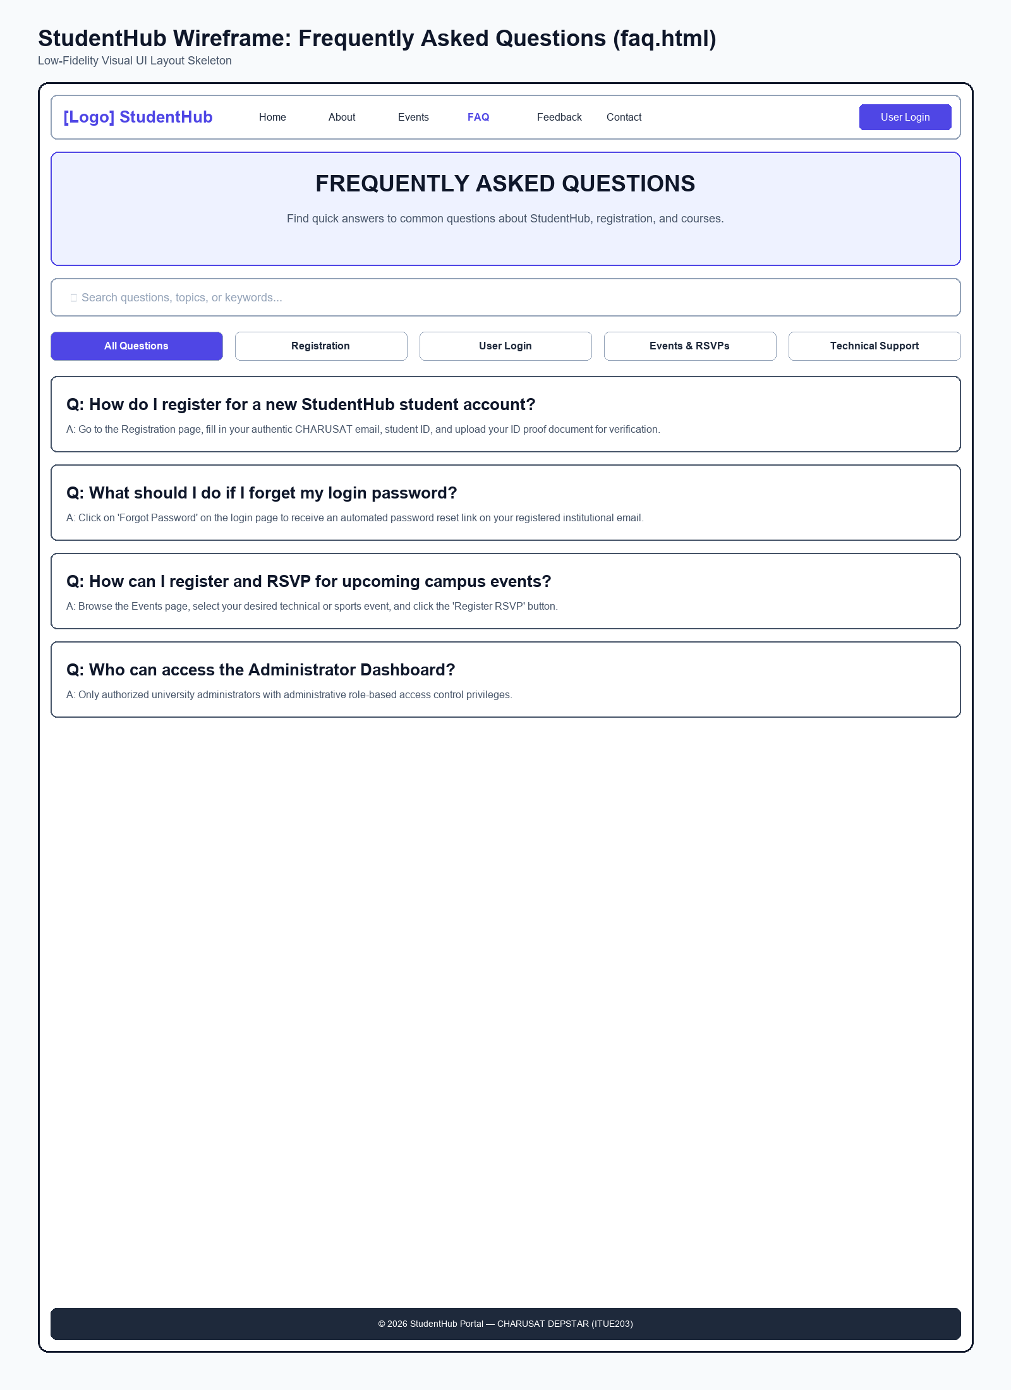
Figure: Wireframe Blueprint layout for FAQ Page

Wireframe - Feedback Survey Page (feedback.html)
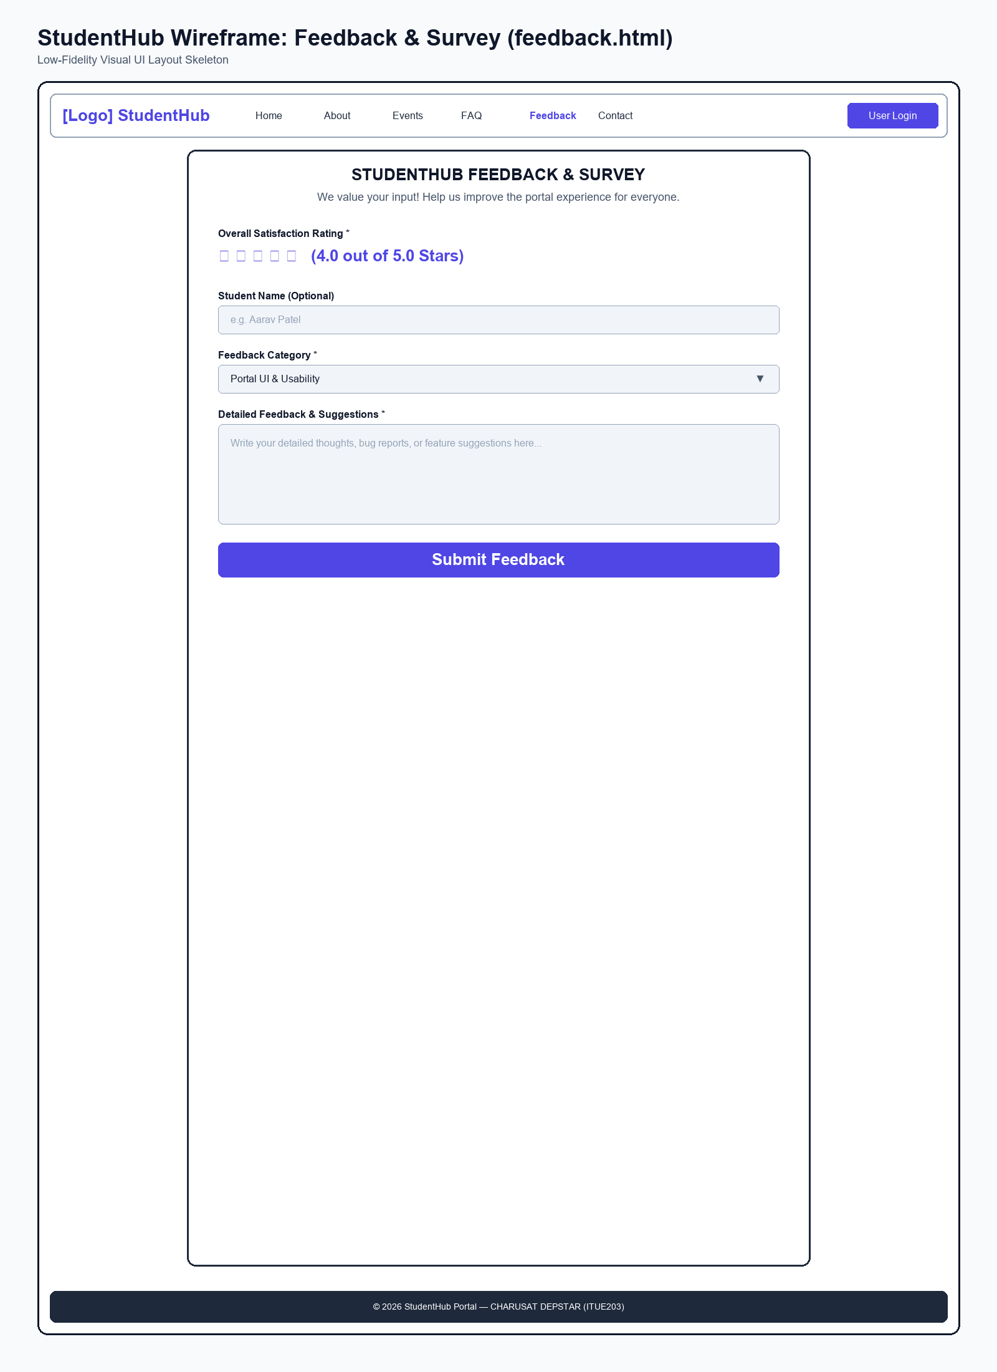
Figure: Wireframe Blueprint layout for Feedback Survey Page

3. Browser Webpage Output Screenshots
These screenshots show the actual rendering of the clean HTML structure of the pages in Google Chrome web browser.

Webpage Output - Home Page (index.html)
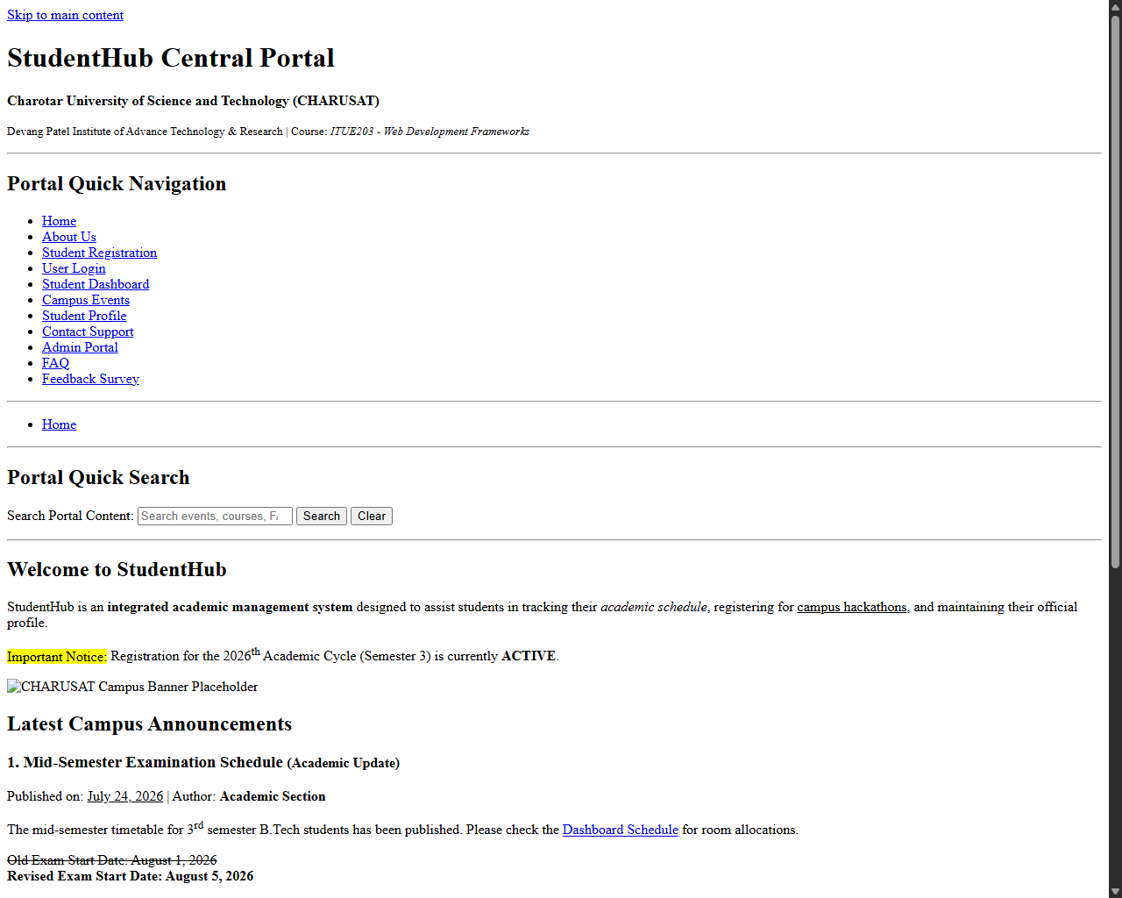
Figure: Browser Output screenshot for Home Page

Webpage Output - About Us Page (about.html)
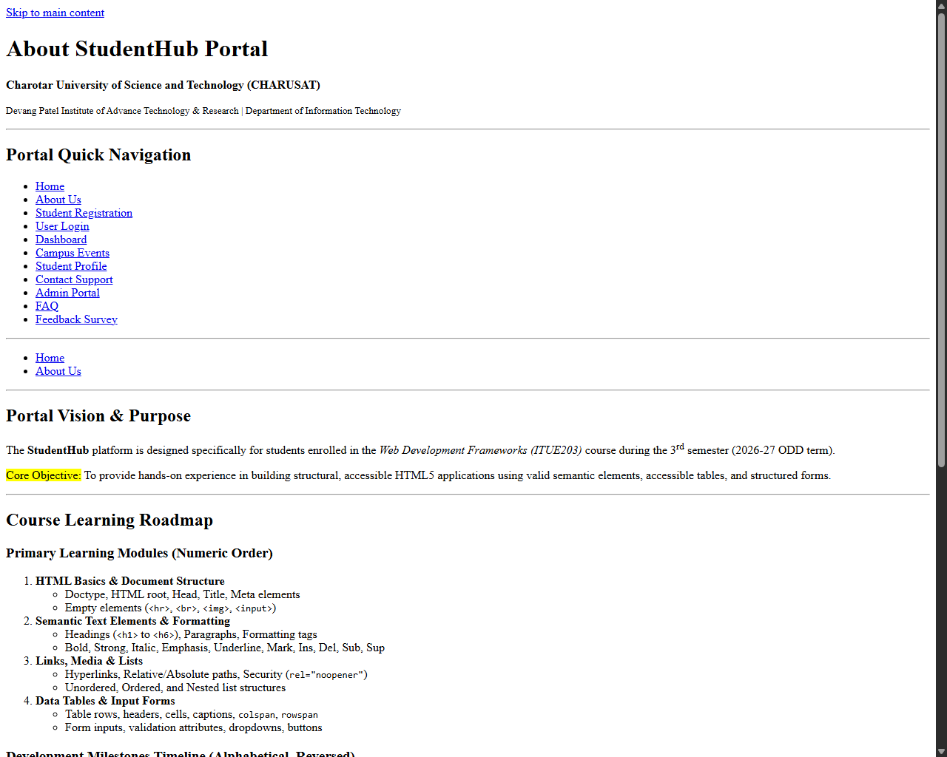
Figure: Browser Output screenshot for About Us Page

Webpage Output - Student Registration Page (register.html)
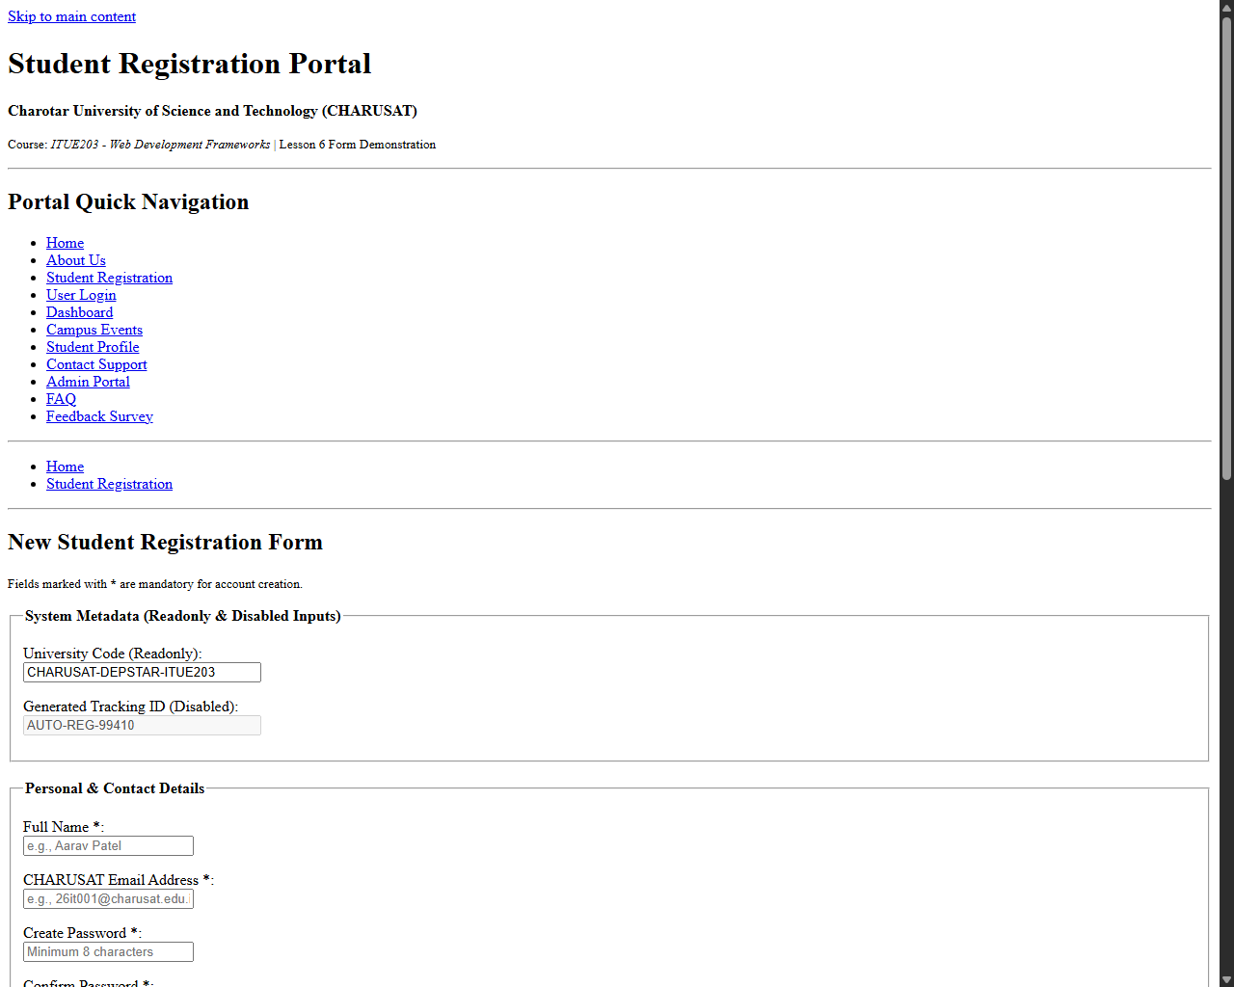
Figure: Browser Output screenshot for Student Registration Page

Webpage Output - User Login Page (login.html)
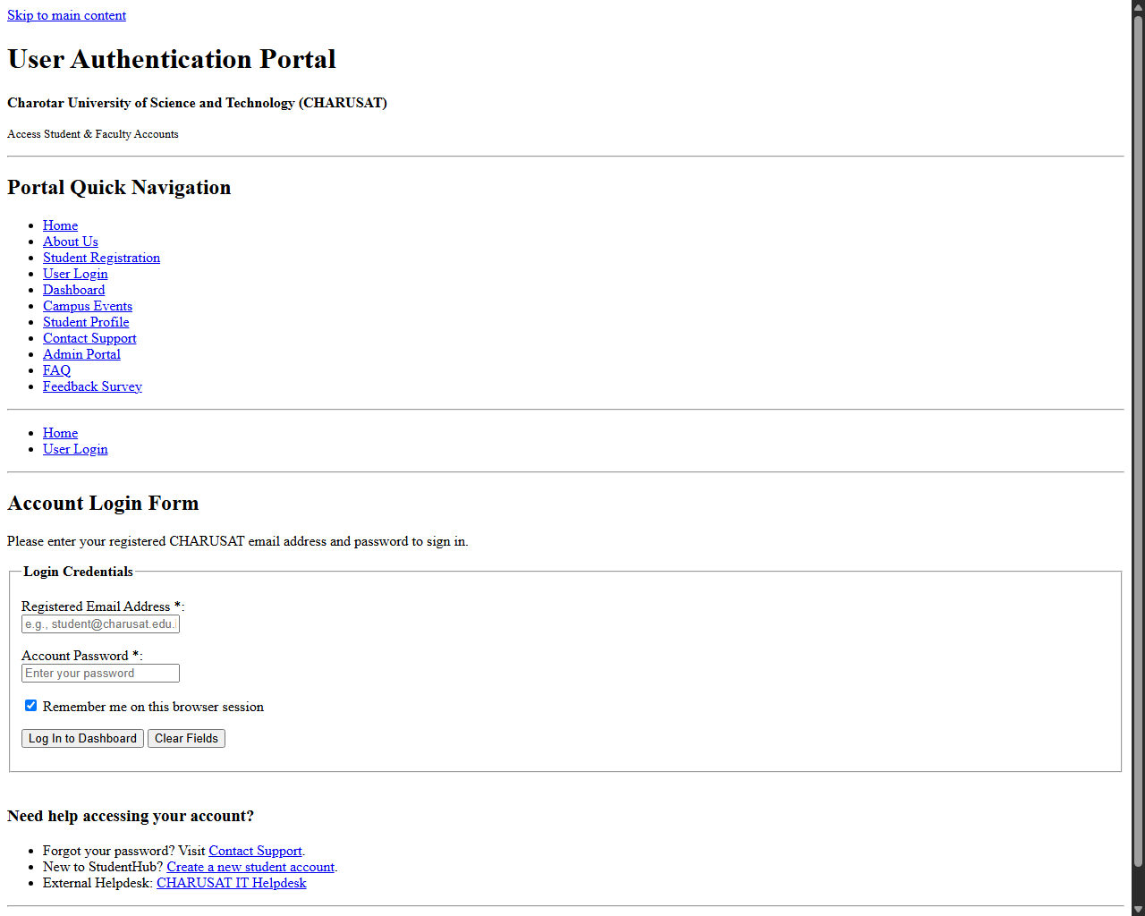
Figure: Browser Output screenshot for User Login Page

Webpage Output - Student Dashboard Page (dashboard.html)
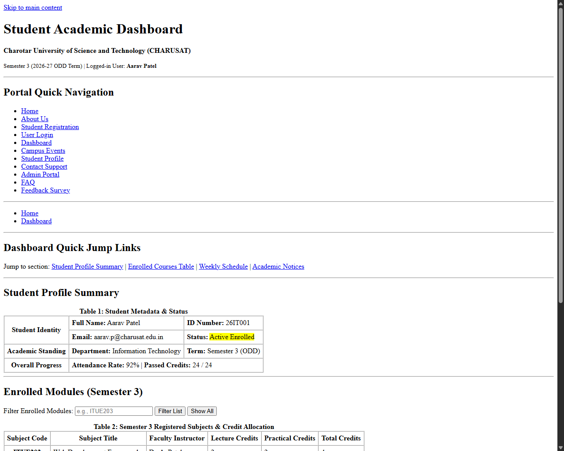
Figure: Browser Output screenshot for Student Dashboard Page

Webpage Output - Campus Events Page (events.html)
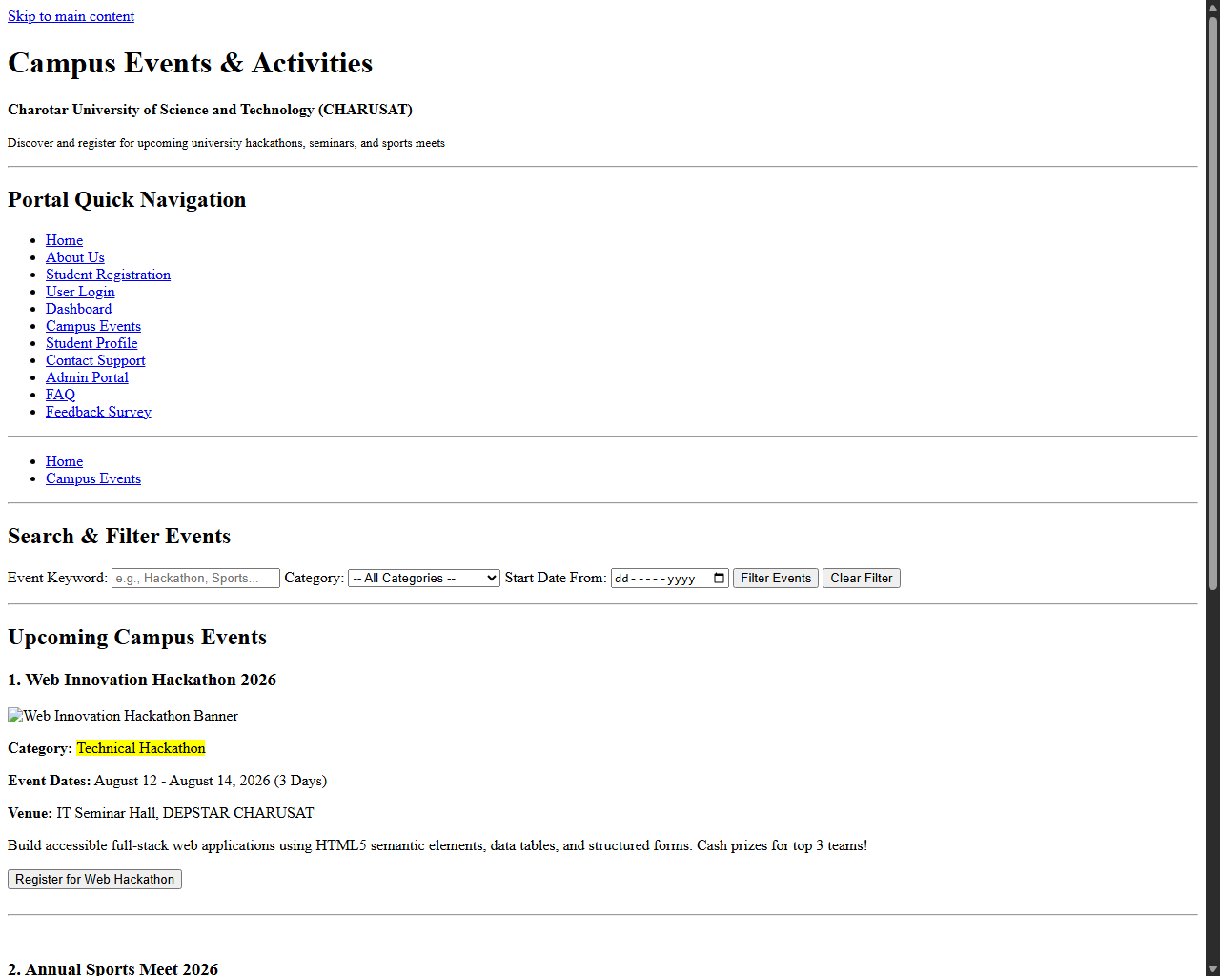
Figure: Browser Output screenshot for Campus Events Page

Webpage Output - Student Profile Page (profile.html)
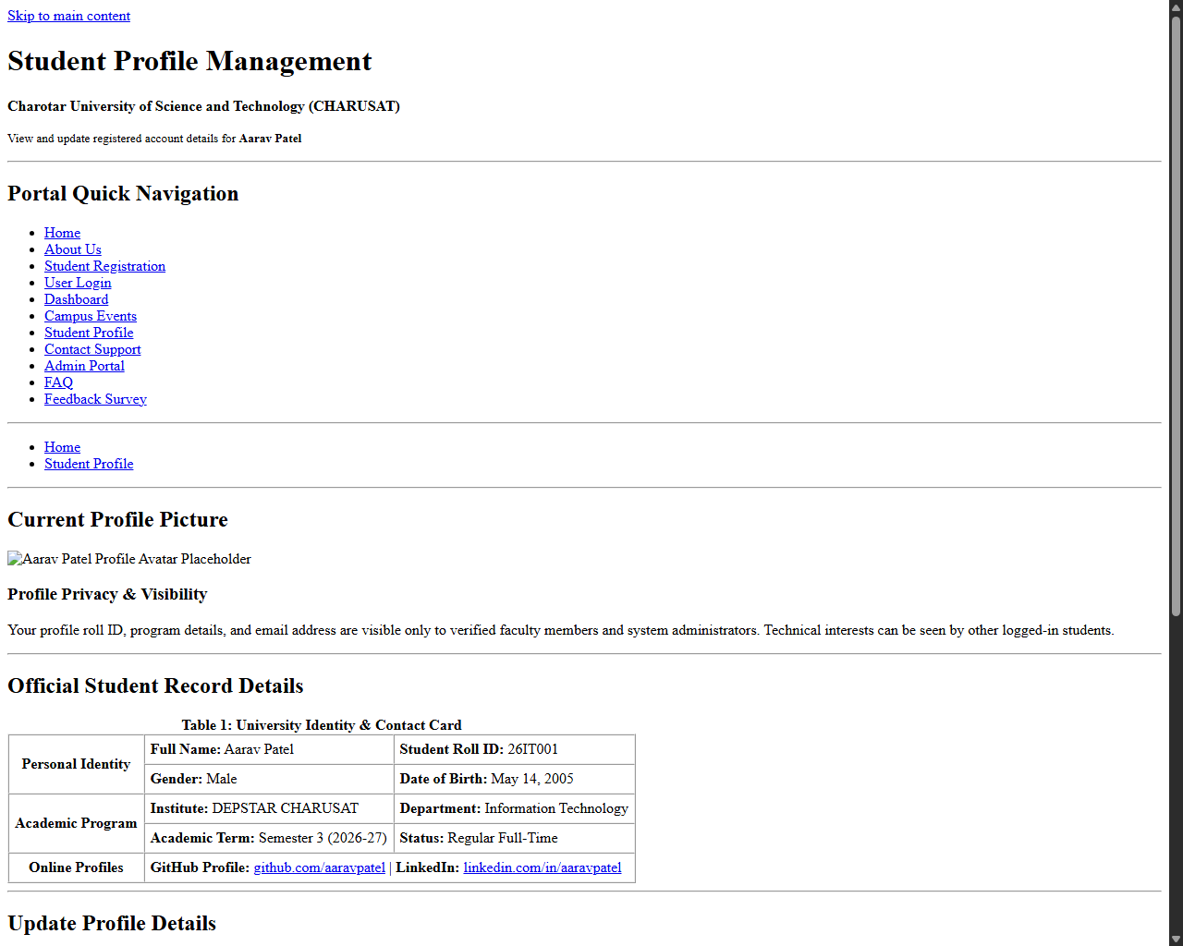
Figure: Browser Output screenshot for Student Profile Page

Webpage Output - Contact Support Page (contact.html)
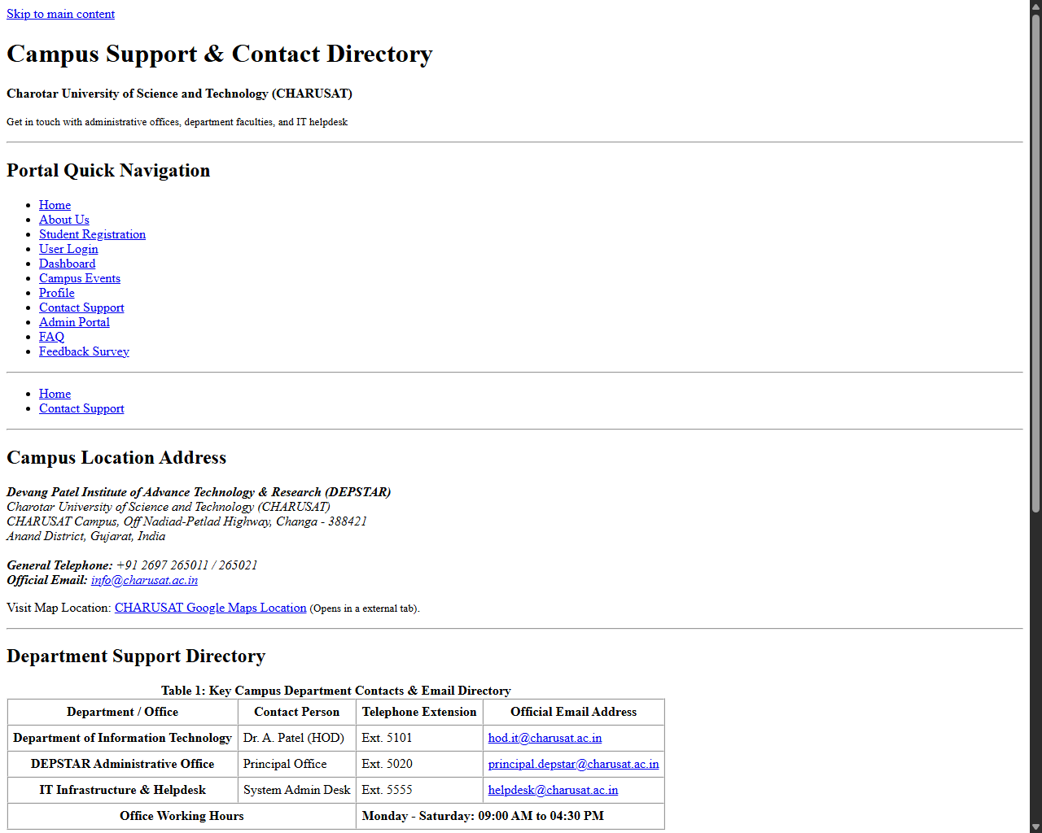
Figure: Browser Output screenshot for Contact Support Page

Webpage Output - Admin Portal Page (admin.html)
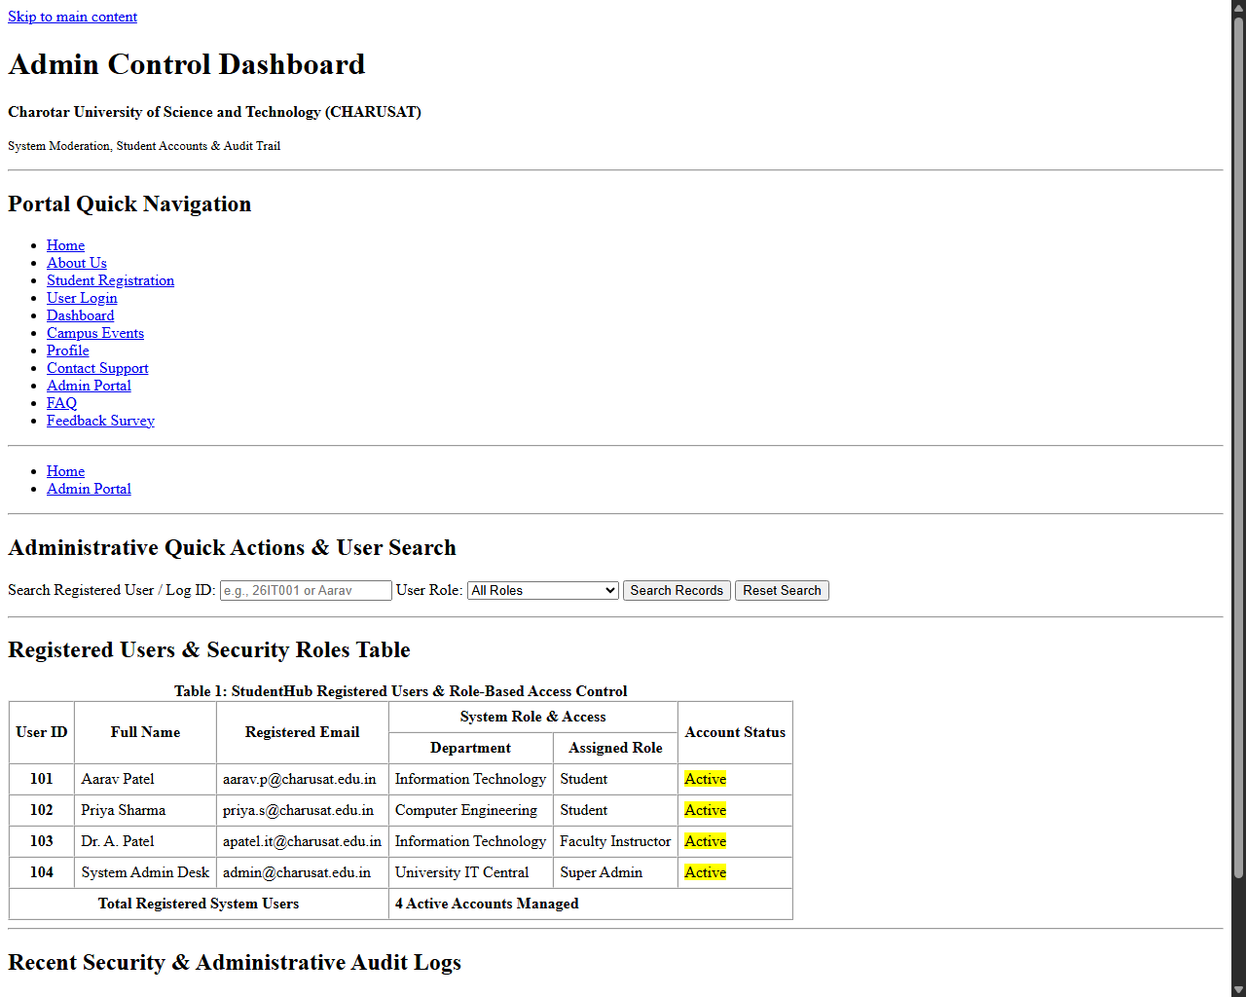
Figure: Browser Output screenshot for Admin Portal Page

Webpage Output - FAQ Page (faq.html)
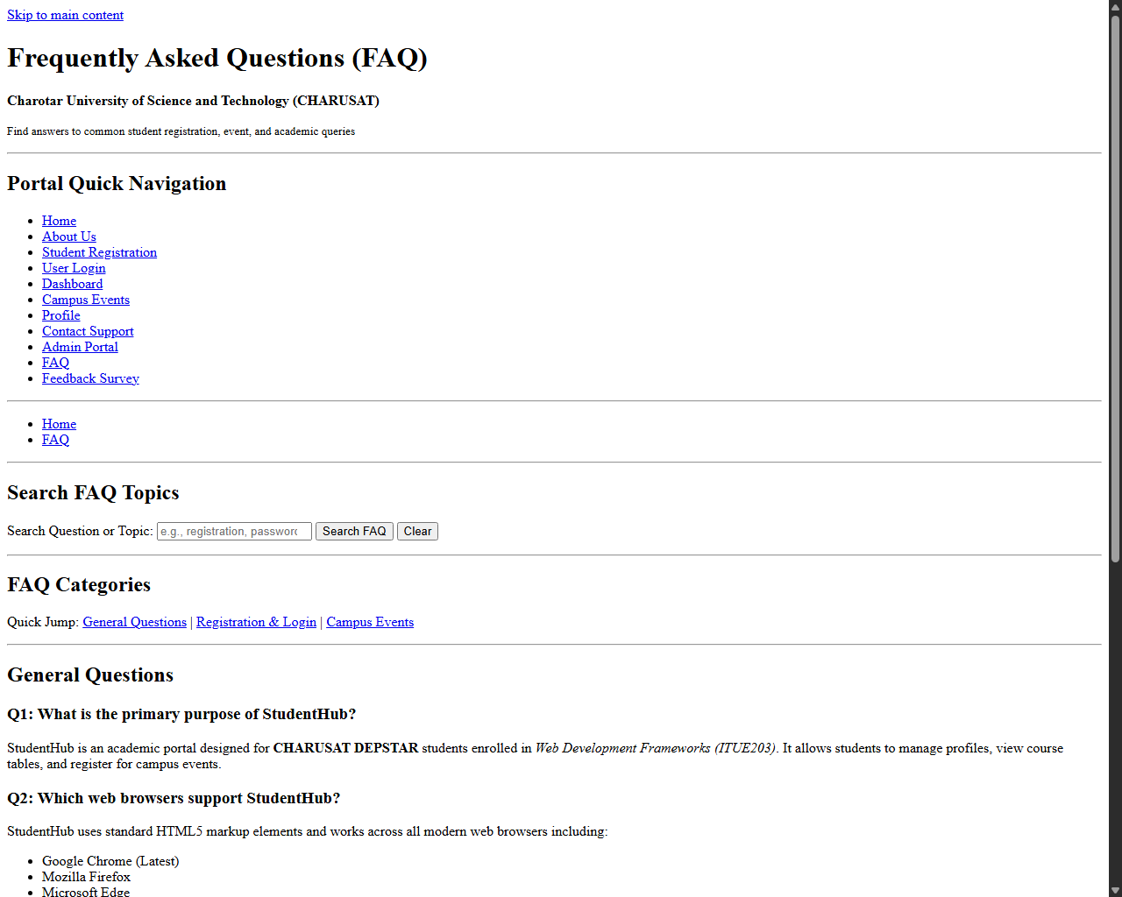
Figure: Browser Output screenshot for FAQ Page

Webpage Output - Feedback Survey Page (feedback.html)
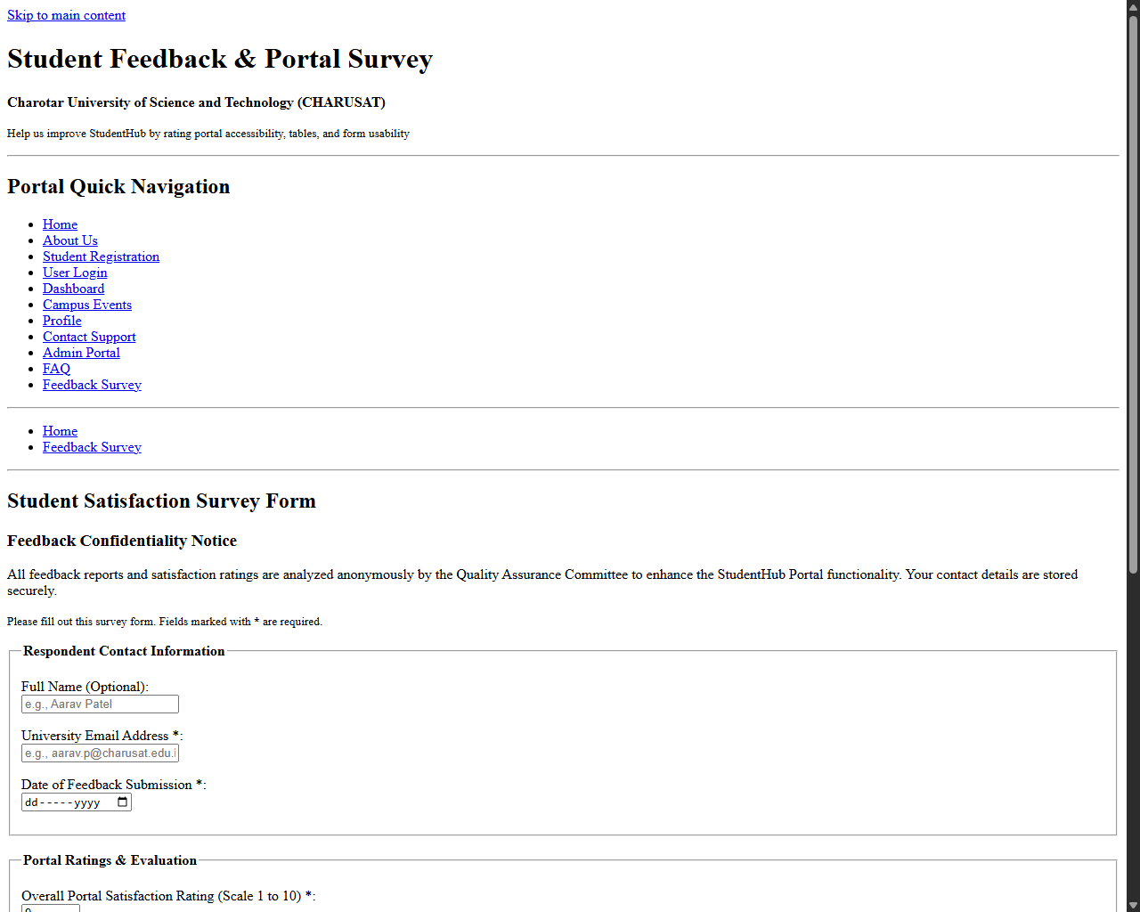
Figure: Browser Output screenshot for Feedback Survey Page

